Public Art Murals, Request for Expression of Interest: Stratford, Prince Edward Island, Canada
Deadline: March 3rd, 2026
Call for Mural Artist Opportunity Overview:
The town of Stratford is seeking to commission two site-specific murals that will be created on site during May – September 2026 and will remain on public display for 5-10 years.
Artwork will engage and connect with the community, transforming locations into inviting and vibrant public spaces.
Murals shall be designed and painted by a qualified artist/muralist who has sufficient knowledge and experience in the painting of such projects, and in the application of the medium selected for the project.
Artists will be selected through an open one stage process. Remuneration includes all costs directly associated with the artwork: including taxes, artists fees, supplies (including anti-graffiti coating), preparation and production fees, equipment rental, accommodations, insurance, lift operating certification (where lift is required), travel expenses, incidental fees.
Applying artists are asked to provide a brief written description of their mural idea along with their portfolio of selected works. If the applying artist does not have a portfolio, we ask that they provide a rough sketch to help with the selection process.
Successful applicants to be approved by our Recreation, Culture and Events Committee before final approval from our Town Council. *In the event where our Committee’s and Town Council are not able to decide between two artists, we will move to shortlist and ask artists to submit a mock-up to be paid each $400.00 (inclusive of all taxes).
Building site preparation work will be completed by Town Staff and inspection to be done by mural artist(s) before painting commences.
Community Background
Stratford, PEI, is a vibrant, fast-growing community, located in Queens County, near Charlottetown. It’s known for its scenic views, offering a mix of residential and commercial development making it a desirable place to live and work. The town is committed to improving the visual appeal to add to the experience of living and visiting areas in our community. The Town’s motto is ‘Imagine That!’ and we ask artists bring their ideas to life and to create a sense of wonder in our community.
ARTWORK LOCATIONS
Location # 1
THEME: Wonder in Water
- This mural will be located on the utility building at Tea Hill Park, Stratford PE.
- 2-sided mural
- Dimensions 1A: 41’ length X 20’ height 1B: 31’ length X 25’ height
- Surface: Metal Siding
- Surrounding Area: Tea Hill Park, Stratford PEI. This building is at Tea Hill Park next to Tea Hill Beach. The area is used by our residents and visitors for the beach, family events, playground, dog walking.
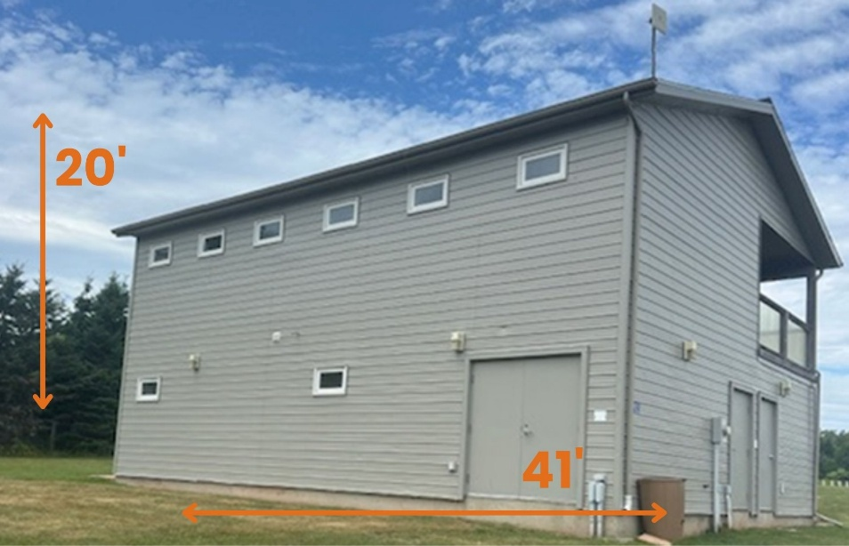
1A

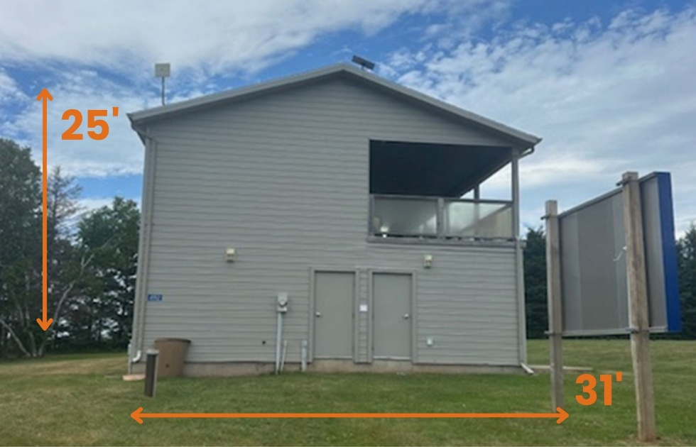
1B

Location # 2
THEME(S): Excitement/Fun, &/Or Dog Themed, &/Or Child Themed
- This mural will be located on the utility building next to the Splash Pad at Town Hall, 234 Shakespeare Drive, Stratford PE.
- 1 OR 2-sided mural (based on application ideas)
- Dimensions 2A: 13’ length X 8’ height (+6 inches concrete) 2B: 6.5’ length X 9.5’ height (+8 inches concrete)
- Surface: Wood Plank
- Surrounding Area: This location is next to the community Splash Pad, fenced dog park/off leash area, and Town Hall

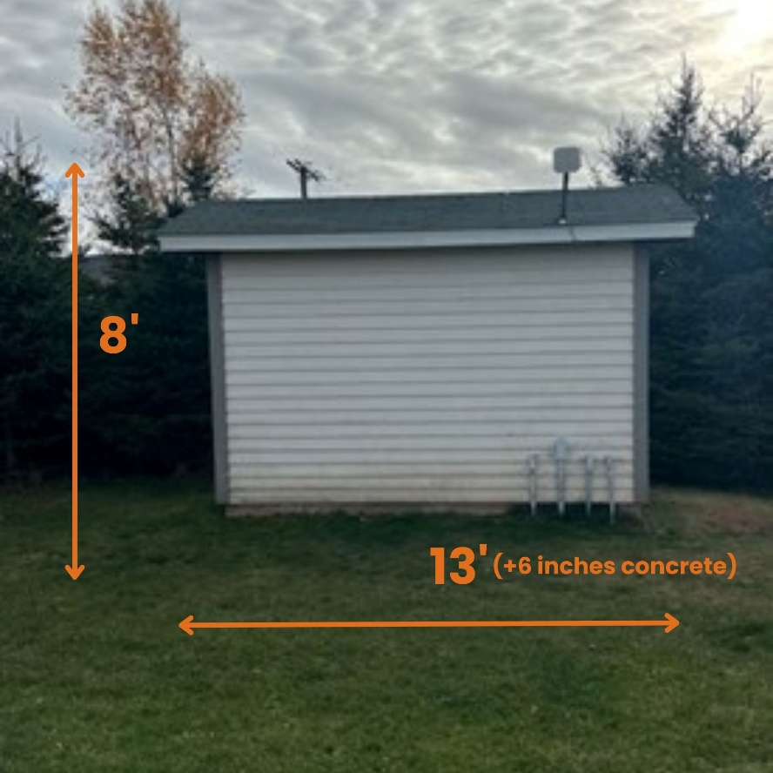
2A

2B (side with door)
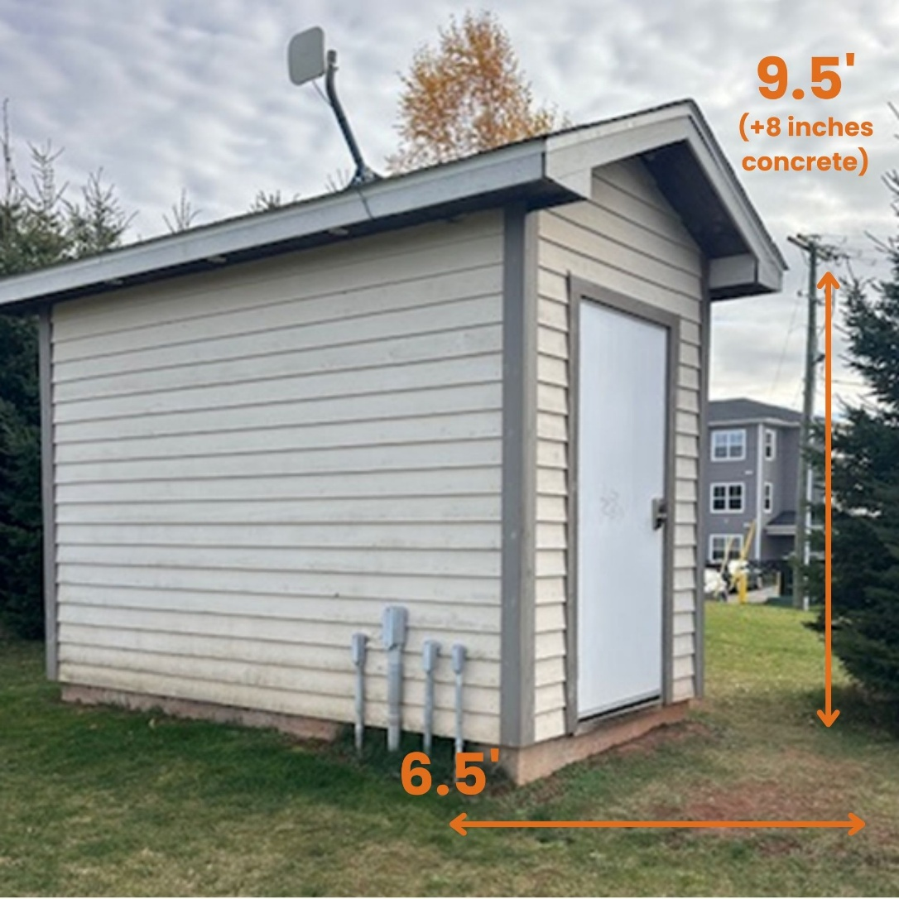

A COMPLETED MURAL APPLICATION MUST BE SUBMITTED TO THE TOWN OF STRATFORD

Submit your Application
All supporting documentation must be sent by email to mweatherbie@townofstratford.ca or by mail to: Melanie Weatherbie, Program and Event Coordinator, Town of Stratford, 234 Shakespeare Drive, Stratford, PE C1B 2V8
A completed application will include the following:
- Artist CV – Supply an artist curriculum vitae for all those working on the mural project. This should include an outline of previous work and achievements including exhibitions, awards, projects, commissions, and reviews, etc. Clearly indicate a project lead or project manager for the team and the roles and responsibilities of various team members (if applicable).
- Past Work/Portfolio – Applicants must submit a maximum of 10 samples of past work that best illustrate their qualifications for this project. Submit each image on a separate page, portrait format, and include title of work, artist(s), location, commissioning agency, date, and budget. If submitting as a team, the team submits no more than 10 images.
- Location chosen.
- Written description of initial idea OR visual representation in absence of a portfolio. Include a written description of initial idea or a rough rendering of proposed mural on the selected geographical location.
- Budget – Submit a budget for the project, including paint, lift (if required), travel and accommodations (if required) etc. *Priming/preparation of site (if required) and permits will be looked after by the Town of Stratford.
- Lift certification (if lift is required for location).
- Schedule – Include a schedule for proposed work; provide a start and end date and/or timeline, detail all key stages, including development, implementation, and delivery.
- Insurance – Provide proof of $2,000,000.00 general liability insurance.
- Please create, if possible, a single file including all attachments and images.

IMPORTANT DATES AND DEADLINES

March 3, 2026: Completed application proposal and supporting materials submission to Town of Stratford by email: mweatherbie@townofstatford.ca or by mail: Melanie Weatherbie, Program and Event Coordinator, Town of Stratford, 234 Shakespeare Drive, Stratford, PE, C1B 2V8.

April 1, 2026: Town of Stratford notification to applicant of acceptance or decline.

May 1, 2026: Project implementation including final design, permissions, and implementation/ installation timeline.

May-September 2026: Project implementation.

September 30, 2026: Completion of project and notification to the Town of Stratford. Completion can occur before this date.

October 30, 2026: Submission of final report and receipts to the Town of Stratford.

ELIGIBILITY
This opportunity is open to art professionals, including but not limited artist teams, designers, mural artists, and visual artists. Artists must be able to complete artwork on site.

THE SUBMISSION MUST ALSO MEET THE FOLLOWING REQUIREMENTS:
Suitability: Artwork that takes into consideration community pride and be complimentary to the Town of Stratford’s theme ‘Imagine That!’.
Originality: Unique expression – the commission is for an original artwork or design. Artwork to be an original design and not a reproduced piece.
Feasibility: Reasonable budget, timeline, and qualifications of participants.
Permanence: Uses high-quality materials that will last a minimum of (5) years and are resistant to vandalism, weather, and ultraviolet deterioration.

ADDITIONALLY, THE PROPOSED MURAL WILL BE REVIEWED FOR THE FOLLOWING DESIGN CRITERIA:
• Artistic quality/excellence: strength of the artist’s concept and demonstrated technical skills and experience.
• Artistic integrity:
- Ideas that are compelling.
- Ideas that contain a consideration of the intended location, community, and the public realm.
- Ideas that are inviting, create an enjoyable experience and engender a sense of community ownership and pride.
- Ideas that enhance community experience.
• Must NOT include political messages or parties or sectarian or religious facility or activity.
• Must only include messages of equality, diversity, and inclusion.
• No graffiti.
• No advertising for a business, advocacy movement, religion, or political party. Cannot include text that advertises a specific business or product, advocacy, religious, or political message. Additionally, trademark symbols, text, and business or artist names are not permitted in any mural. One exception is the 10% up to one-square metre at the bottom of a mural where artist names may be listed.
• No tags or acronyms are permitted in the artwork, only wording approved by the Town of Stratford.
• Must not include any inappropriate or controversial wording or images in the artwork.
• Must be suitable for public of all ages.

COPYRIGHT AND MORAL RIGHTS

Copyright including any and all designs, drawings, and final works of art shall remain the property of the artist. Moral rights remain with the artist. The Town of Stratford has permission to reproduce the images for non-profit publicity purposes. The final image must be the same as the image submitted in the application and not changed without prior written consent and agreement from the Town of Stratford.

ACTIVITIES NOT FUNDED

• Murals that include political messages or parties or sectarian or religious facility or activity;
• Capital works, facility maintenance, and improvements;
• Ongoing running costs;
• Items of equipment or clothing of a personal nature;
• Provision of meals and snacks;
• Social events and parties;
• Illegal graffiti.

ADDITIONAL FACTORS

• It is strongly recommended that the artist(s) visit and/or research the Town of Stratford before submitting a proposal.
• This proposal request creates no obligation on the part of the Town of Stratford to award the contract or to reimburse proponents for the application process.
• The Town reserves the right to accept or reject any and all proposals, in whole or in part, received as a result of this request, and to negotiate in any manner necessary to best serve the interest of the Town of Stratford.
• At the election of the Town of Stratford, whether or not a proposal or proponent otherwise satisfies the requirements of the proposal request, the Town of Stratford may reject summarily any proposal received from a corporation or other person which has been anywise involved in litigation, arbitration or alternative dispute resolution with the Town of Stratford within the five (5) year period immediately preceding the date on which the request for Proposals was published.
• The Town of Stratford may prohibit a proponent from participating in a procurement process based on past performance or based on inappropriate conduct in a prior procurement process, and such inappropriate conduct shall include but not be limited to the following:
(a) the submission of quotations containing misrepresentations or any other inaccurate, misleading or incomplete information; (b) the refusal of the proponent to honour its pricing or other commitments made in its proposal; or (c) any other conduct, situation or circumstance, as solely determined by the Town of Stratford.

THE FINAL SELECTION COMMITTEE WILL FAVOUR IN THIS ORDER:
- Quality of artwork
- Theme of artwork in fitting with location and overall theme of ‘Imagine That!’
- Artists based in Prince Edward Island
- Artists based in Canada
- Artists based Internationally

WHO MAKES THE DECISIONS?
The Recreation, Culture and Events Committee will present final selection to Town Council for approval to award the contract.

QUESTIONS:
Any questions in respect to this proposal request should be directed to:
Program and Event Coordinator
Melanie Weatherbie
mweatherbie@townofstratford.ca
(902) 569-6925

